MINI PROJECT – Electronic waste Recyclability

Cohort – 12 DSML
Sl.No | Member Name | Assigned Role
1 | Dhanyashree K | Data Collection
2 | Shreelatha G | Fine tuning
3 | Peeyush Suryan | Data Cleaning and Feature Engineering
4 | Gurugula Surya Chenna Siva Sankar Reddy | Data Collection
5 | Rajendra Gowda M | Data Cleaning and Feature Engineering
6 | Rohan M E | Data Collection
7 | Sukhi R | Model Training
8 | Sowjanya B M | Documentation
9 | Gagan H R | Model Training
10 | Bharath M | Data Cleaning and Feature Engineering
11 | Saniya Kousar T | Fine tuning
12 | Tasbeeha F | Model Training
13 | Madan b d | Data Cleaning and Feature Engineering
14 | Nandish R | Documentation
15 | Imrankhan Ghori | Not Active

DAY 1 – Problem Statement Allocation and Initial Research
Date: 6th March 2026
Present Members: Dhanyashree K, Shreelatha G, Peeyush Suryan, Gurugula Surya Chenna Siva Sankar Reddy, Sukhi R, Saniya Kousar T, Rajendra Gowda M, Sowjanya B M, Madan b d, Bharath M, Rohan M E, Gagan H R, Nandish R, Tasbeeha F
Note: The members listed under Present Members are those who attended the daily meeting on this date.
Absent Members: Imrankhan Ghori (inactive)

Work Done:
- Conducted a team meeting to discuss insights from initial research on the problem statement.
- Shared understanding of the project requirements among team members.
- Distributed tasks and assigned roles and responsibilities.
- Established deadlines for each assigned task.
The Project Objective:
- Classify discarded electronic components as recoverable or non-recoverable using material composition data.
- Develop and train a machine learning model to perform the classification.
- Evaluate model performance using overall classification accuracy.
- Fine-tune categorical embedding dimensions for rare earth metals to improve model performance.
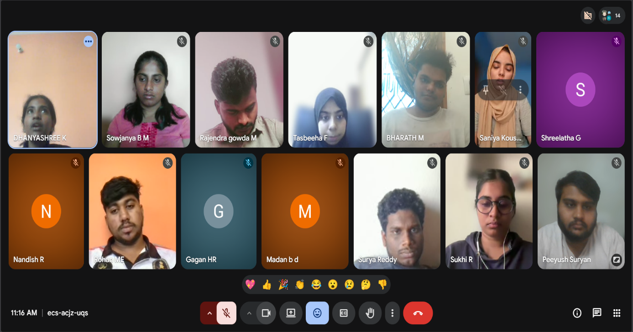

DAY 2 – Role Allocation and Environmental Data Acquisition
Date: 9th March 2026
Present Members: Dhanyashree K, Shreelatha G, Peeyush Suryan, Gurugula Surya Chenna Siva Sankar Reddy, Sukhi R, Saniya Kousar T, Rajendra Gowda M, Madan b d, Bharath M, Rohan M E, Gagan H R, Sowjanya B M, Tasbeeha F
Absent Members: Imrankhan Ghori, Nandish R
Work Done:
1. Project Discussion and Repository Setup
A team meeting was conducted to begin the technical work for the mini project and discuss the overall approach for handling the electronic waste dataset. The discussion focused on understanding the problem statement and planning the workflow for dataset analysis, preprocessing, and model development.
To maintain version control and collaborative development, the President created a GitHub repository where team members were instructed to push their respective contributions and updates.
Link:
https://github.com/DhanyaSvit/E-waste-Recyclability

2. Dataset Acquisition
The Data Collection Team explored and gathered relevant datasets related to electronic waste composition and recoverability.
The dataset used for this project:
Dataset Name: e_waste_dataset_with_profit.csv (Source – Kaggle)
Dataset Size:
10,000 electronic components
Key Dataset Features:
Component Identification:
- Item Name
- Category (Cat1 – Cat4)
Material Composition (in grams):
- Gold
- Silver
- Platinum
- Rhodium
- Nickel
- Tin
- Lithium
- Aluminum
- Carbon
Additional Fields:
- Profit reference value
These features represent the material composition of electronic components, which directly influences the economic feasibility of recovering valuable metals during recycling.
3. Initial Dataset Understanding
The team performed an initial inspection of the dataset to understand its structure and suitability for machine learning.
Preliminary checks included:
- Reviewing dataset shape and structure
- Inspecting column names and data types
- Viewing sample records
- Identifying potential missing values
This analysis confirmed that the dataset contained material composition data necessary to estimate recoverability of electronic components.
4. Technical Relevance Assessment
The team analyzed whether the collected features in the E-waste dataset support the objective of estimating the profit from recyclable electronic waste materials.
- Item: Represents the type of electronic product such as phones, appliances, or speakers that generate e-waste.
- Category: Classifies the electronic item into different product groups for better analysis.
- Gold: Indicates the quantity of gold present in the electronic component, which contributes to recycling value.
- Silver: Represents the amount of silver that can be recovered from the device.
- Platinum: Shows the presence of platinum, a valuable rare metal used in electronic circuits.
- Rhodium: Represents another rare and high-value metal found in electronic components.
- Nickel: Indicates the amount of nickel available in the device materials.
- Tin: Represents tin content used in soldering and electronic connections.
- Lithium: Shows the lithium amount commonly found in batteries and energy storage components.
- Aluminum: Indicates recyclable aluminum content present in electronic structures.
- Carbon: Represents carbon-based material contribution within the device composition.
- Profit ($): This is the target variable representing the estimated profit that can be obtained from recycling the electronic item.
5. Documentation
The documentation team recorded the following details:
- Project objective and SDG alignment
- Role allocation and team responsibilities
- Dataset source and structure
- Initial dataset understanding process
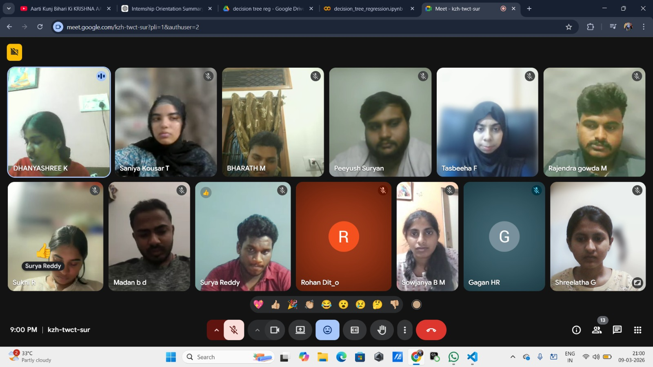
DAY 3 – Data Cleaning, Feature Engineering and Preprocessing
Date: 10th March 2026
Present Members: Dhanyashree K, Shreelatha G, Peeyush Suryan, Gurugula Surya Chenna Siva Sankar Reddy, Sukhi R, Saniya Kousar T, Rajendra Gowda M, Madan b d, Bharath M, Rohan M E, Gagan H R, Tasbeeha F, Sowjanya B M
Absent Members: Imrankhan Ghori, Nandish R
Work Done:
1. Workflow Discussion
A team meeting was conducted to discuss the data preprocessing pipeline and feature preparation strategy.
The goal of this stage was to transform the raw electronic waste dataset into a machine learning-ready dataset capable of supporting classification models.
2. Data Cleaning and Missing Value Treatment
The Data Cleaning Team performed several preprocessing operations to ensure data quality and consistency.
The following steps were carried out:
- Identification of missing values across numerical features
- Median imputation applied to handle missing values
- Validation of numerical data types
- Verification of dataset consistency
Median imputation was selected because it is robust against extreme values and outliers.
3. Outlier Detection and Removal
To maintain realistic material composition values, outlier detection was performed using the Interquartile Range (IQR) method.
The process involved:
- Applying the 1.5 × IQR rule to detect extreme values
- Performing outlier removal sequentially for all nine metal composition columns
Metals analyzed:
- Gold
- Silver
- Platinum
- Rhodium
- Nickel
- Tin
- Lithium
- Aluminum
- Carbon
This step removed unrealistic extreme compositions while preserving overall dataset integrity.
4. Economic Value Engineering
A major step in the preprocessing pipeline involved creating a recoverability label based on economic value.
Total Value Calculation
The total economic value of each electronic component was calculated using 2026 industry scrap metal prices per gram.
Key metal prices included:
- Gold – $62/g
- Rhodium – $155/g
- Platinum – $81/g
- Silver – $0.95/g
The Total_Value feature represents the aggregate monetary value of recoverable metals present in each component.
Recoverability Classification
To classify components into recoverable and non-recoverable, a threshold-based labeling strategy was applied.
- Threshold selected: 65th percentile of Total_Value distribution
- Components above the threshold labeled as Recoverable (1)
- Remaining components labeled as Non-Recoverable (0)
This resulted in a realistic distribution where approximately:
- 35% components were economically recoverable
- 65% components were non-recoverable
This distribution aligns with real-world recycling economics, where only a portion of electronic waste is profitable to recover.
5. Data Export
After completing preprocessing and feature engineering, the dataset was exported.
Output Dataset:
e_waste_cleaned_recoverable.csv
Dataset Characteristics:
- Approximately 8,500 rows
- 14 columns
- Includes engineered features:
  - Total_Value
  - Recoverable
The Recoverable column was positioned as the target variable for supervised classification modeling.
6. Validation Metrics
The preprocessing pipeline validated key dataset statistics including:
- Recoverability threshold value
- Class distribution (35% / 65%)
- Final Total_Value statistics
- Confirmation of zero missing values
7. Documentation
The documentation team recorded:
- Data cleaning methodology
- Outlier detection approach
- Feature engineering process
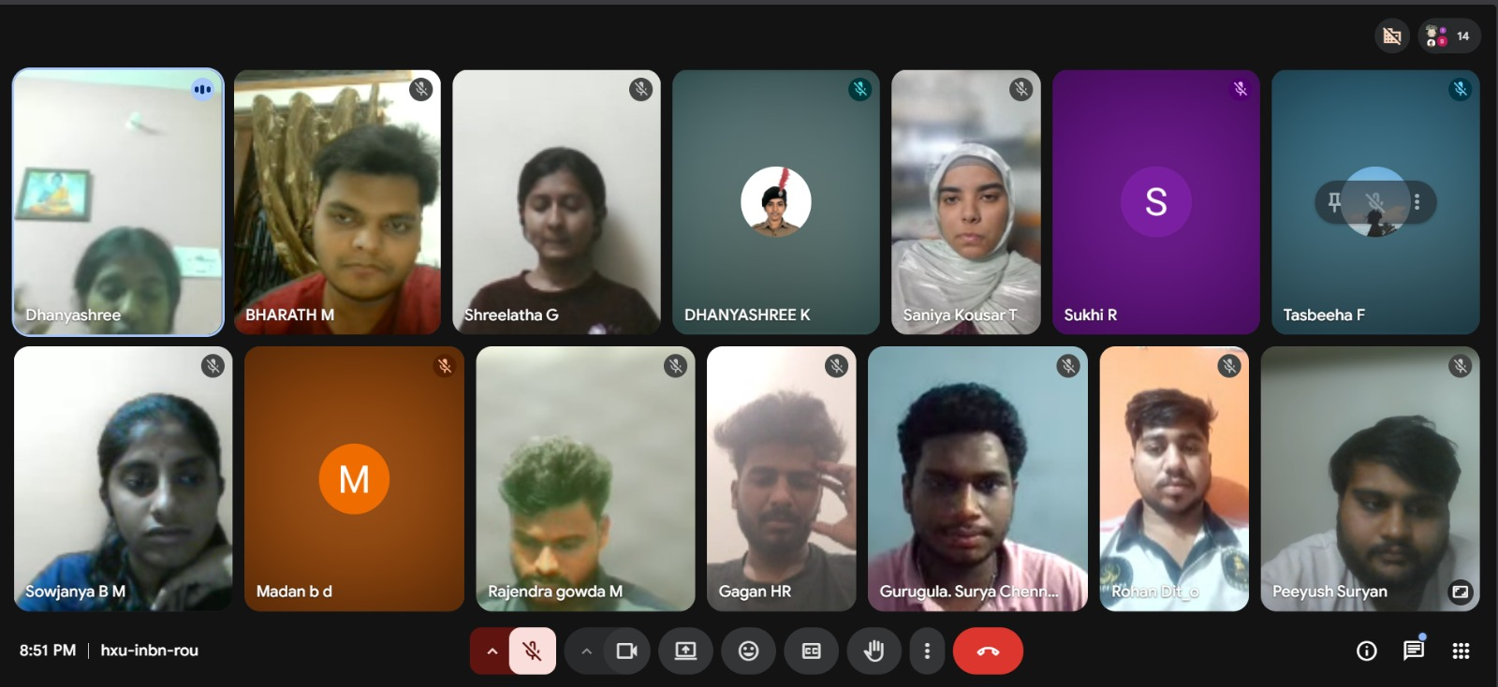
- Dataset export and validation details
DAY 4 – Model Training, Fine tuning and Comparative Analysis
Date: 11th March 2026
Present Members: Dhanyashree K, Shreelatha G, Peeyush Suryan, Gurugula Surya Chenna Siva Sankar Reddy, Saniya Kousar T, Rajendra Gowda M, Bharath M, Sowjanya B M, Sukhi R, Rohan M E
Absent Members: Imrankhan Ghori, Nandish R, Gagan, Madan b d, Tasbeeha F
Work Done:
1. Team Meeting
A team meeting was conducted to discuss the model training strategy and algorithm selection.
Since the objective of the project was to classify electronic components as recoverable or non-recoverable, classification algorithms were selected.
2. Model Training
The Model Training Team implemented multiple machine learning models using the cleaned dataset.
The dataset was split into training and testing sets using an 80-20 train-test split.
Target Variable:
- Recoverable (1 = Recoverable, 0 = Non - Recoverable)
3. Models Implemented
Decision Tree Classifier
A Decision Tree model was trained as the initial classification approach.
Observed Performance:
- Accuracy: 94%
Decision Trees provided interpretable classification rules but showed slightly lower performance compared to ensemble methods.
Random Forest Classifier
A Random Forest Classifier was implemented as an ensemble approach combining multiple decision trees.
Observed Performance:
- Accuracy: 97%
Random Forest performed better due to:
- Reduced overfitting
- Better generalization
- Improved handling of complex feature relationships

4. Feature Importance Analysis
Feature importance analysis was performed using the Random Forest model.
Key observations:
- Rhodium
- Platinum
- Gold
were identified as the most influential metals affecting recoverability prediction.
This confirms that precious metals strongly influence recycling profitability.
5. Model Evaluation
The trained model was evaluated using:
- Confusion Matrix
- Classification Report
- Precision
- Recall
- F1 Score
- Overall Accuracy
The evaluation confirmed that the model was capable of accurately distinguishing recoverable and non-recoverable components.
6. Documentation
The documentation team recorded:
- Models implemented
- Evaluation metrics obtained
- Feature importance observations
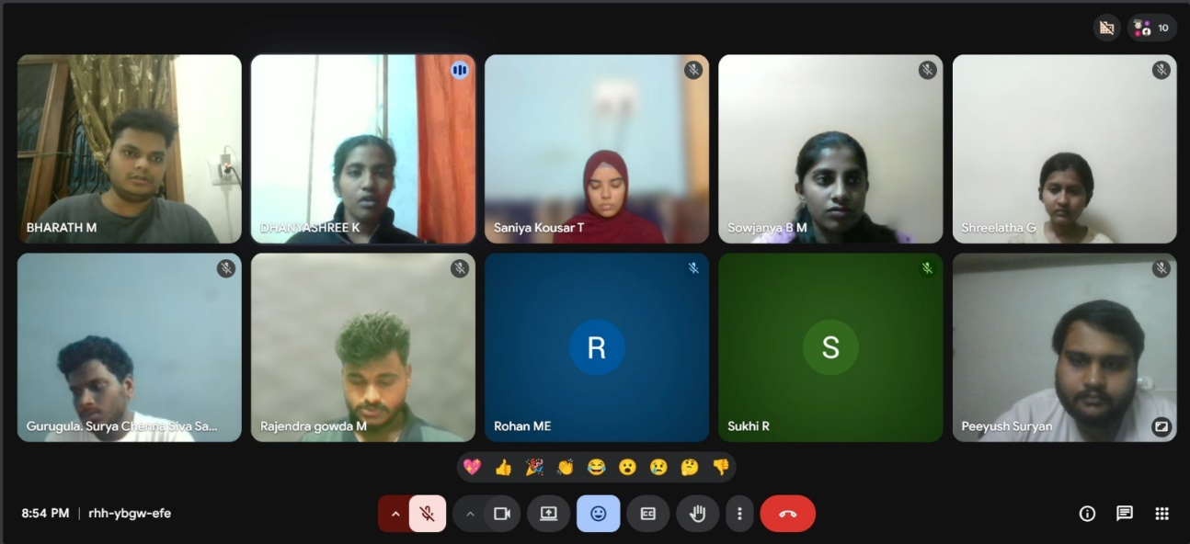
- Model performance analysis
DAY 5 – Model Finalization and Performance Review
Date: 12th March 2026
Present Members: Dhanyashree K, Shreelatha G, Peeyush Suryan, Gurugula Surya Chenna Siva Sankar Reddy, Saniya Kousar T, Bharath M, Sowjanya B M , Rajendra Gowda M, Madan b d, Tasbeeha F, Sukhi R,
Absent Members: Imrankhan Ghori, Gagan H R, Rohan M E, Nandish R
Work Done:
1. Fine Tuning Strategy
After obtaining strong baseline results with the Random Forest model, the Fine-Tuning Team worked on optimizing the model parameters.
Hyperparameter tuning was performed using GridSearchCV, which systematically tests multiple parameter combinations to identify the best performing configuration.
2. Hyperparameter Optimization
The following parameters were tuned:
- Number of Trees (n_estimators)
- Maximum Tree Depth (max_depth)
- Minimum Samples for Split (min_samples_split)
- Minimum Samples per Leaf (min_samples_leaf)
The tuning process used:
- 5-fold Cross Validation
- F1 Macro Score as evaluation metric
Total model combinations tested: 24
3. Best Model Parameters
The optimal Random Forest configuration identified by GridSearchCV was:
- n_estimators: 200
- max_depth: 15
- min_samples_split: 5
- min_samples_leaf: 1
4. Final Model Performance
After fine tuning, the model achieved the following performance:
Tuned Model Accuracy:
97.9%
Classification Results:
- Precision ≈ 0.98 – 0.99
- Recall ≈ 0.95 – 0.99
- F1 Score ≈ 0.97 – 0.98
The model demonstrated strong capability in correctly identifying both:
- Recoverable components
- Non-recoverable components
Confusion Matrix
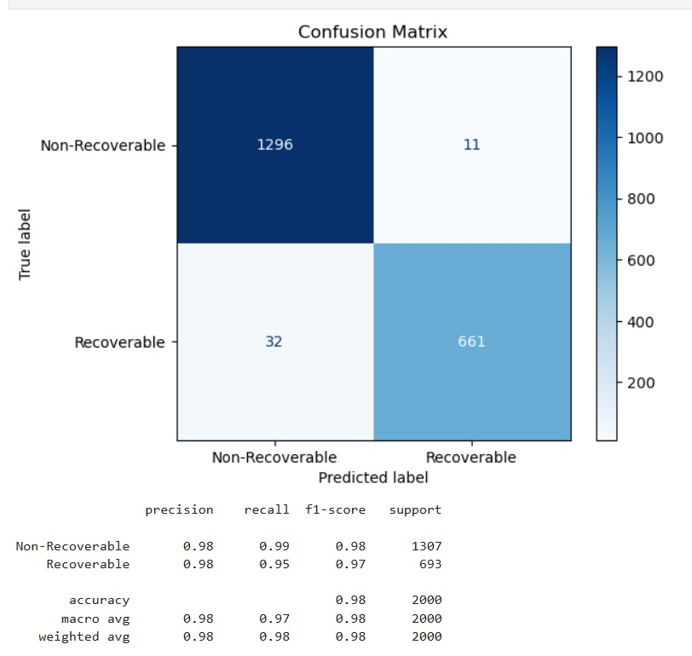Figure: Confusion Matrix for E-Waste Recoverability Classification
Observation:
- 1296 components correctly classified as Non-Recoverable
- 661 components correctly classified as Recoverable
- Very few misclassifications occurred, indicating strong model performance.
Classification Report
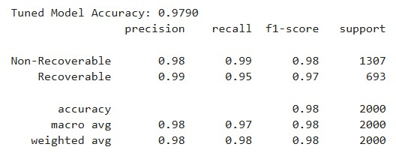
Figure: Classification Metrics for Tuned Random Forest Model
The classification report summarizes the precision, recall, F1-score, and support for each class, confirming balanced and reliable classification performance.
5. Final Predictions and Result Export
To improve interpretability, the model predictions were combined with item names from the dataset.
The final output included:
- Item Name
- Actual Recoverability Label
- Predicted Recoverability Label
Results were exported as:
ewaste_predictions.csv
This output allows easy verification of model predictions for specific electronic components.
6. Final Outcome of Day 5
- Random Forest selected as the final classification model
- Hyperparameter tuning completed using GridSearchCV
- Final accuracy improved to 97.9%
- Model evaluation completed using confusion matrix and classification metrics
- Final predictions generated and exported
- Documentation completed and prepared for submission

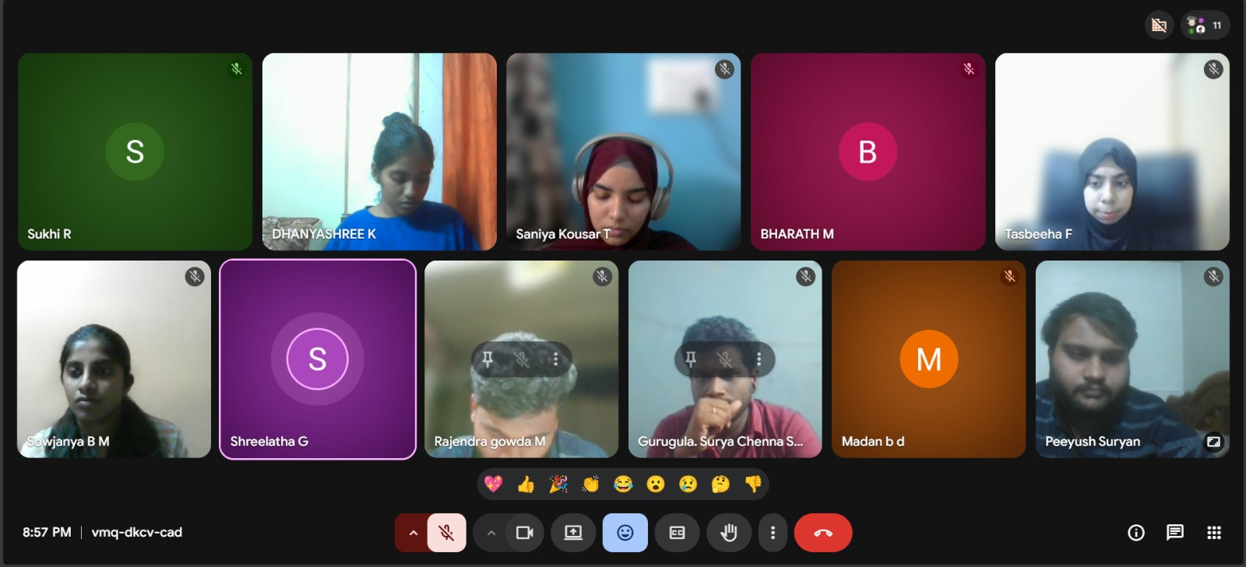

Sl. No | Member Name | Role | Rating (0–5) | Remarks
1 | Dhanyashree K | Data Collection | 4.8 | Coordinated team tasks, and developed an approach to better align dataset classification with project requirements.
2 | Shreelatha G | Fine Tuning | 4.5 | Actively contributed through dataset research, model fine-tuning, and supporting project documentation.
3 | Peeyush Suryan | Data Cleaning and feature Engineering | 4.6 | Supported dataset research, actively worked on data cleaning, and maintained team attendance documentation.
4 | Gurugula Surya Chenna Siva Sankar Reddy | Data Collection | 4.5 | Actively contributed to dataset collection and participated in team meetings and review discussions.
5 | Rajendra Gowda M | Data Cleaning and feature Engineering | 5 | Showed active participation and worked efficiently as part of the data cleaning team.
6 | Rohan M E | Data Collection | 3.5 | Contributed to dataset collection and participated in team meetings and discussions.
7 | Sukhi R | Modelling Training | 4.8 | Actively participated in the project and worked effectively on model training using Decision Tree.
8 | Sowjanya B M | Documentation | 4.5 | Maintained complete and timely documentation throughout the project in a professional and organized manner.
9 | Gagan H R | Modelling Training | 3 | Participated in some team discussions but had limited contribution to the project due to personal circumstances.
10 | Bharath M | Data Cleaning and feature Engineering | 5 | Demonstrated strong team engagement and contributed to preparing the dataset through cleaning tasks.
11 | Saniya Kousar T | Fine Tuning | 5 | Contributed through active collaboration and supported the fine-tuning and evaluation of the model.
12 | Tasbeeha F | Modelling Training | 5 | Actively participated in the project and worked on training the Random Forest model, which was later finalized by the team.
13 | Madan b d | Data Cleaning and feature Engineering | 3.25 | Despite limited network access, he collaborated with another team member to contribute to the project.
14 | Nandish R | Documentation | 3 | Was part of the documentation team and attended meetings, though active contribution was limited.
15 | Imrankhan Ghori | Not active | -------- | ------------------------------------------------------------

